Module 04 Lab 02 Model Development Laptop Pricing Screenshot Evidence and Discussion
Reference label for this notebook: Lab2 (each heading below is numbered Lab2_1, Lab2_2 and so on).
This document gathers the screenshots of Module 04 Lab 02, model development on the laptop pricing dataset, and follows the four tasks of the notebook in order. The lab fits a single variable regression on CPU_frequency, a multiple regression on the six strongest attributes, polynomial regressions of several degrees and finally a pipeline that combines scaling, polynomial features and linear regression. Each screenshot file name is printed below its image.

Lab2_1. Section 0 Setup and the libraries used in the lab
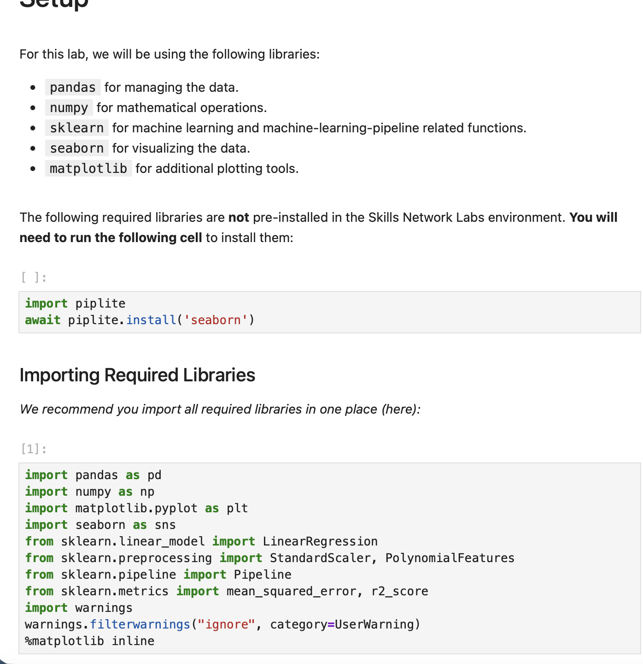
Screenshot file: 1_setup_and_import_libraries.png
The setup lists the libraries for the whole lab: pandas for the data, scikit-learn for the estimators, and matplotlib and seaborn for the plots.

Lab2_2. Section 0 Downloading the laptop dataset
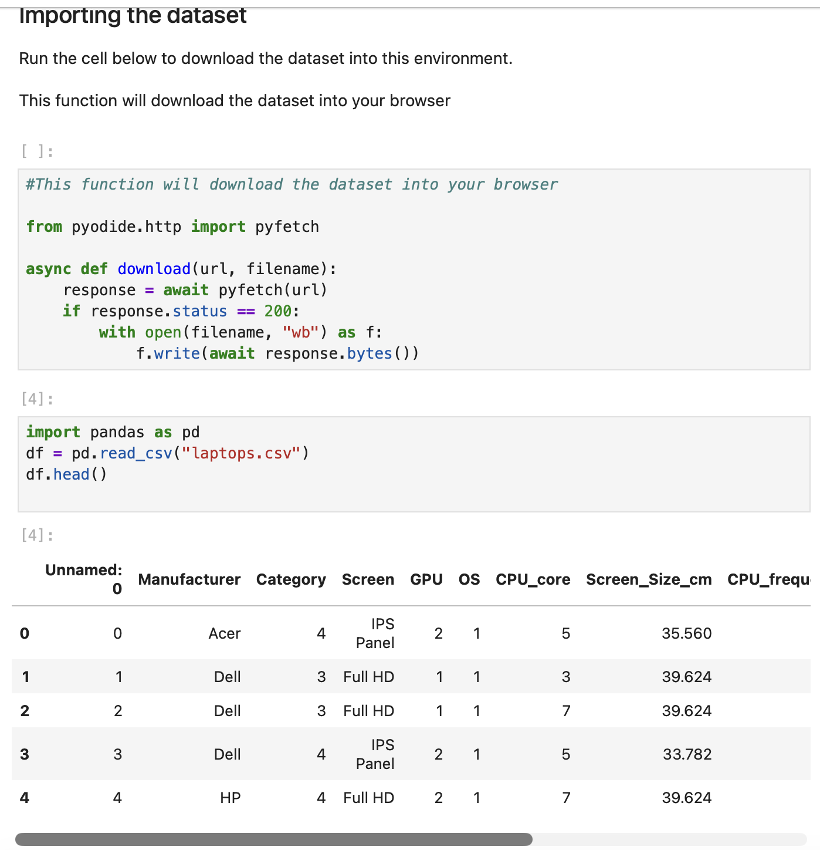
Screenshot file: 2_import_dataset_laptops.png
The download helper stores the prepared laptop file so the dataframe can be built from a local copy.

Lab2_3. Section 0 Loading the dataset and previewing it
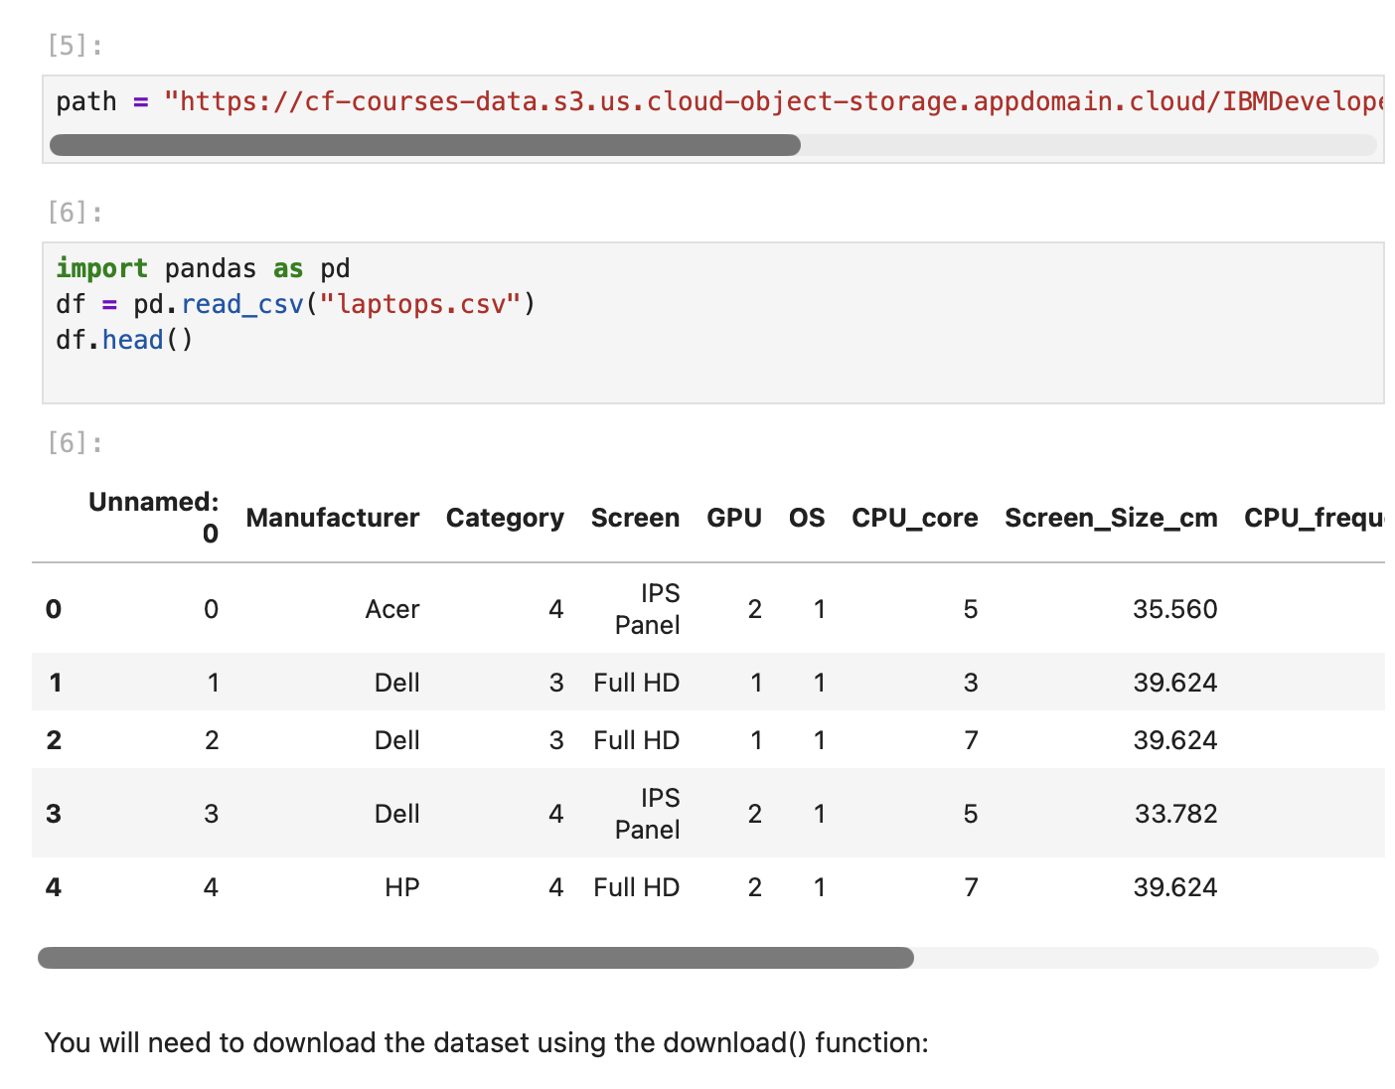
Screenshot file: 3_load_laptops_data_head.png
pd.read_csv reads the prepared file and df.head() shows the first rows with the engineered attributes of the laptops.

Lab2_4. Section 0 Preview of the loaded dataframe
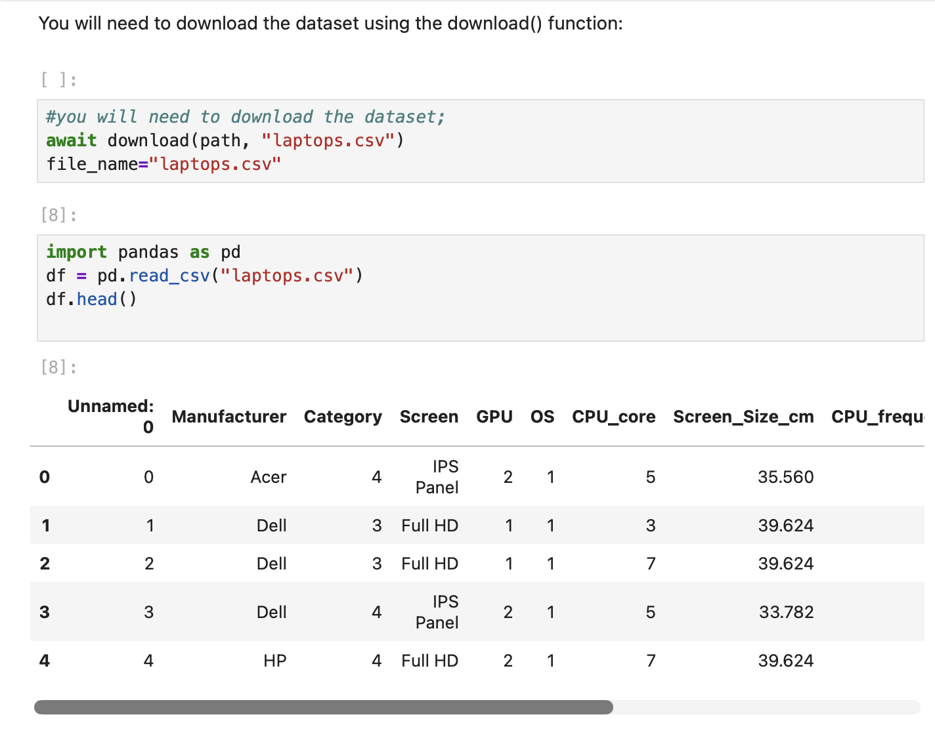
Screenshot file: 4_download_and_preview_laptops_data.png
The same load is shown with the head of the frame, which confirms the 238 laptops and the attribute set used by the models.

Lab2_5. Section 0 Reading the CSV with its header row
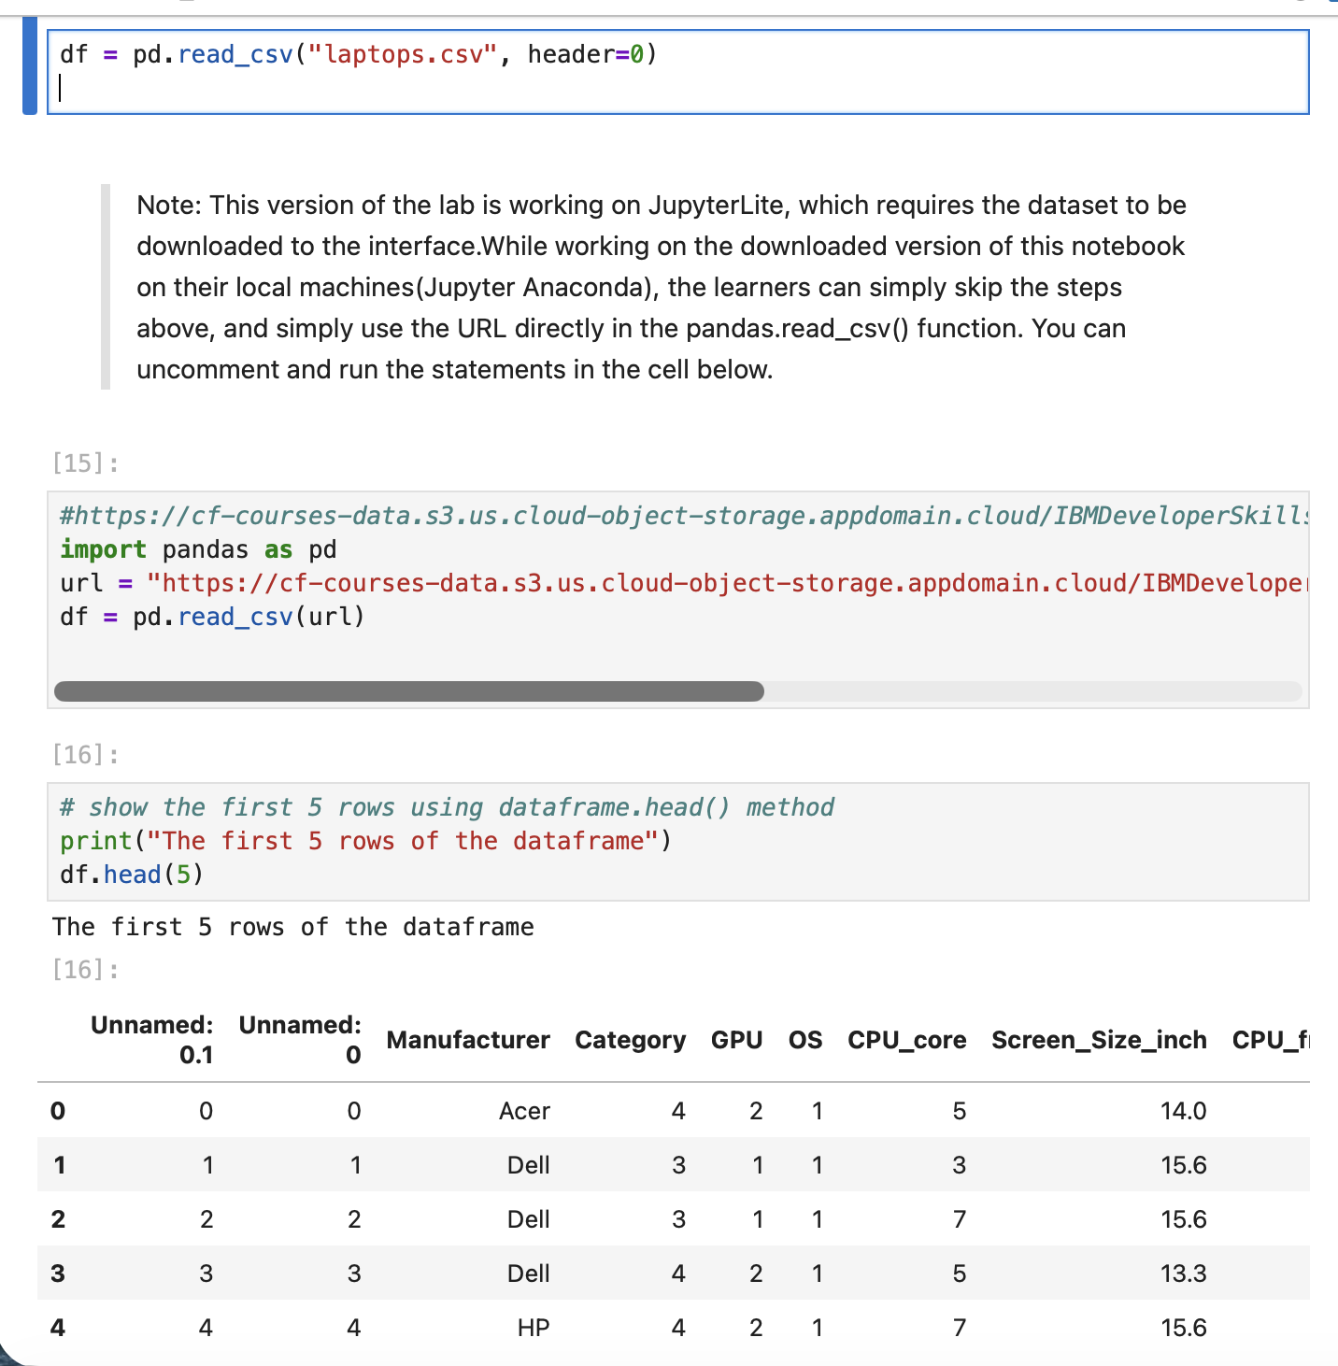
Screenshot file: 5_read_csv_with_header_and_head5.png
The note about the JupyterLite download is followed by the read that takes the column names from the file itself.

Lab2_6. Task 1 Single linear regression with CPU_frequency
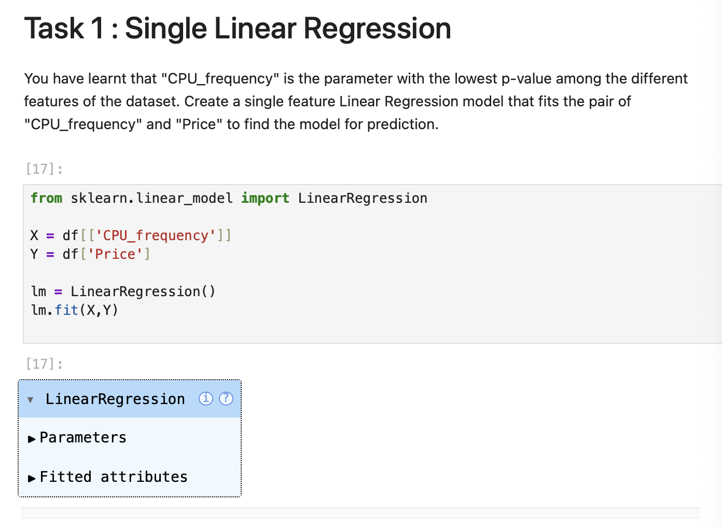
Screenshot file: 6_task1_single_linear_reg_cpu_frequency_price.png
CPU_frequency is used as the single predictor of Price because it was the attribute with the lowest p value in the previous module.

Lab2_7. Task 1 Comparing actual and fitted prices
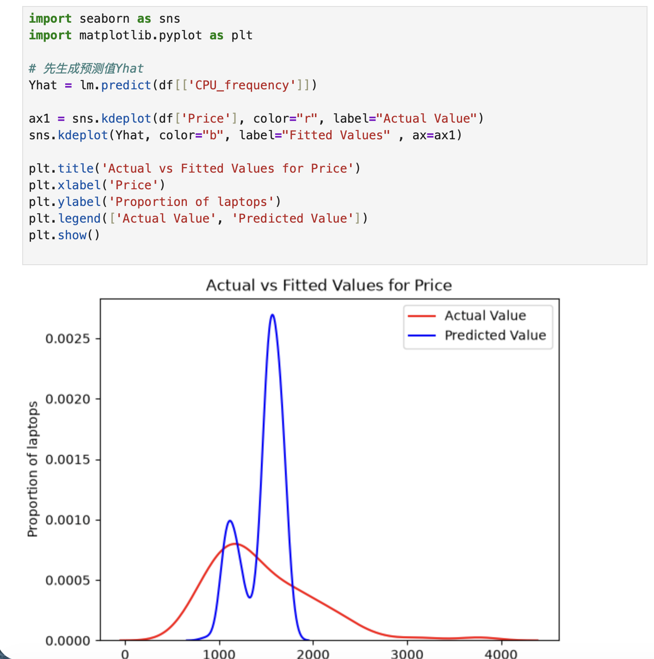
Screenshot file: 7_task1_kdeplot_actual_vs_fitted_price.png
The distribution plot puts the actual prices next to the values predicted by the single feature model.

Lab2_8. Task 1 R squared and mean squared error of the single feature model
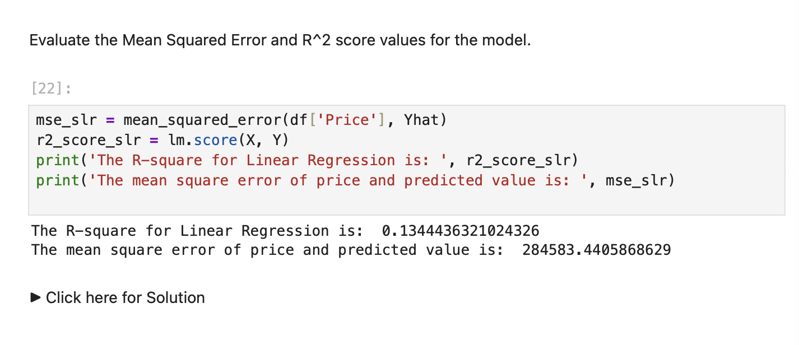
Screenshot file: 8_task1_slr_mse_r2_evaluation.png
The model reaches an R squared of about 0.13 and the mean squared error is printed next to it, the baseline for the following tasks.

Lab2_9. Task 2 Multiple linear regression
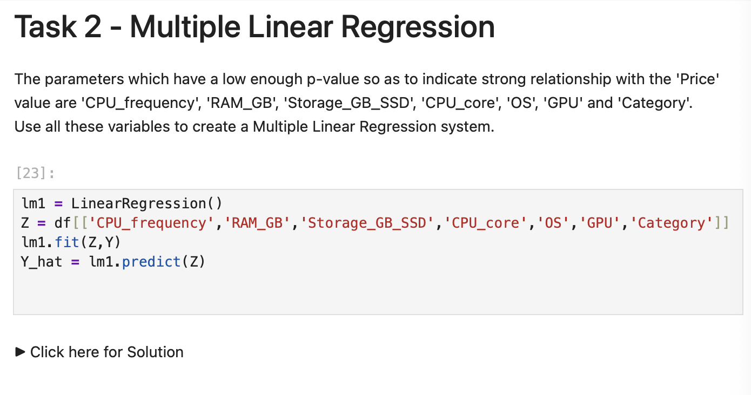
Screenshot file: 9_task2_multiple_linear_regression.png
The model is trained on the six attributes that the correlation analysis had shown to be related to price.

Lab2_10. Task 2 Comparing the multiple regression with the actual prices
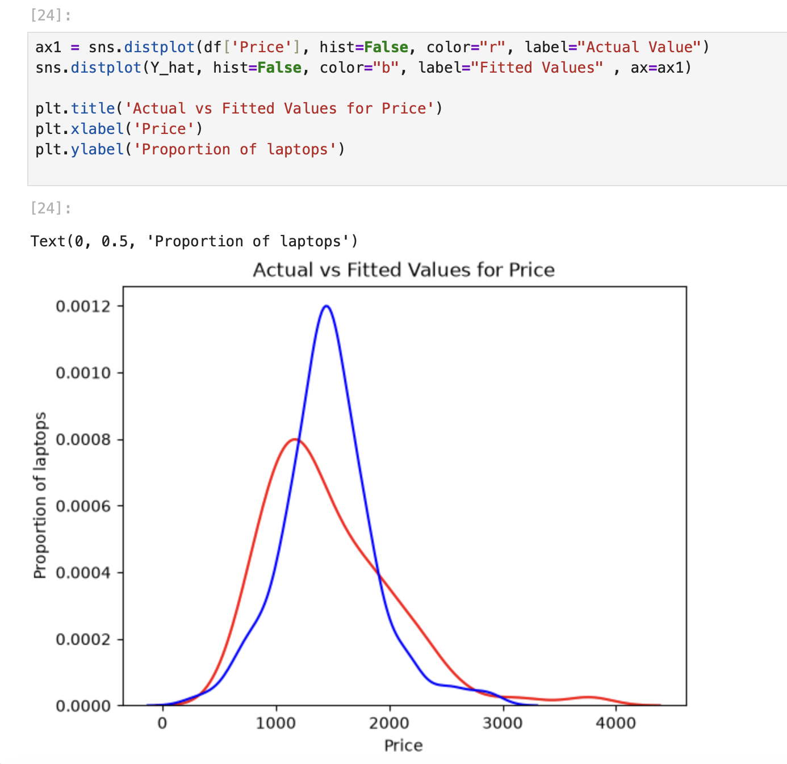
Screenshot file: 10_task2_kdeplot_actual_vs_fitted_price.png
The fitted distribution is much closer to the actual prices than in Task 1, which shows the effect of adding features.

Lab2_11. Task 2 Distribution plot of the actual and fitted prices
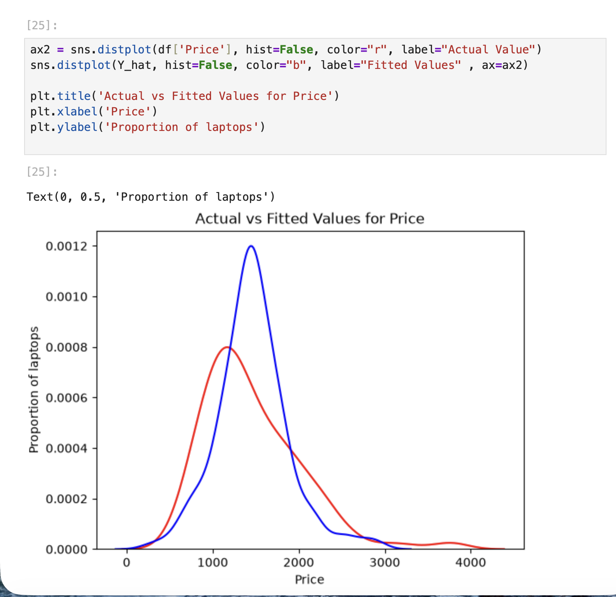
Screenshot file: 11_task2_distplot_actual_vs_fitted_price.png
The same comparison is drawn as a distribution plot so the two curves can be compared directly.

Lab2_12. Task 3 Polynomial regression with CPU_frequency
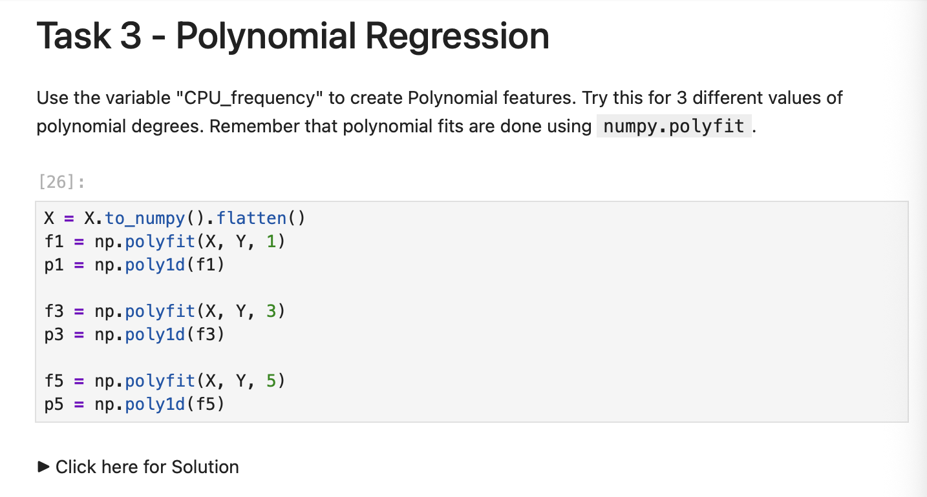
Screenshot file: 12_task3_polynomial_reg_numpy_polyfit.png
Polynomial fits of several degrees are produced with numpy.polyfit, following the polynomial regression section of the lab.

Lab2_13. Task 3 Defining the polynomial plot helper
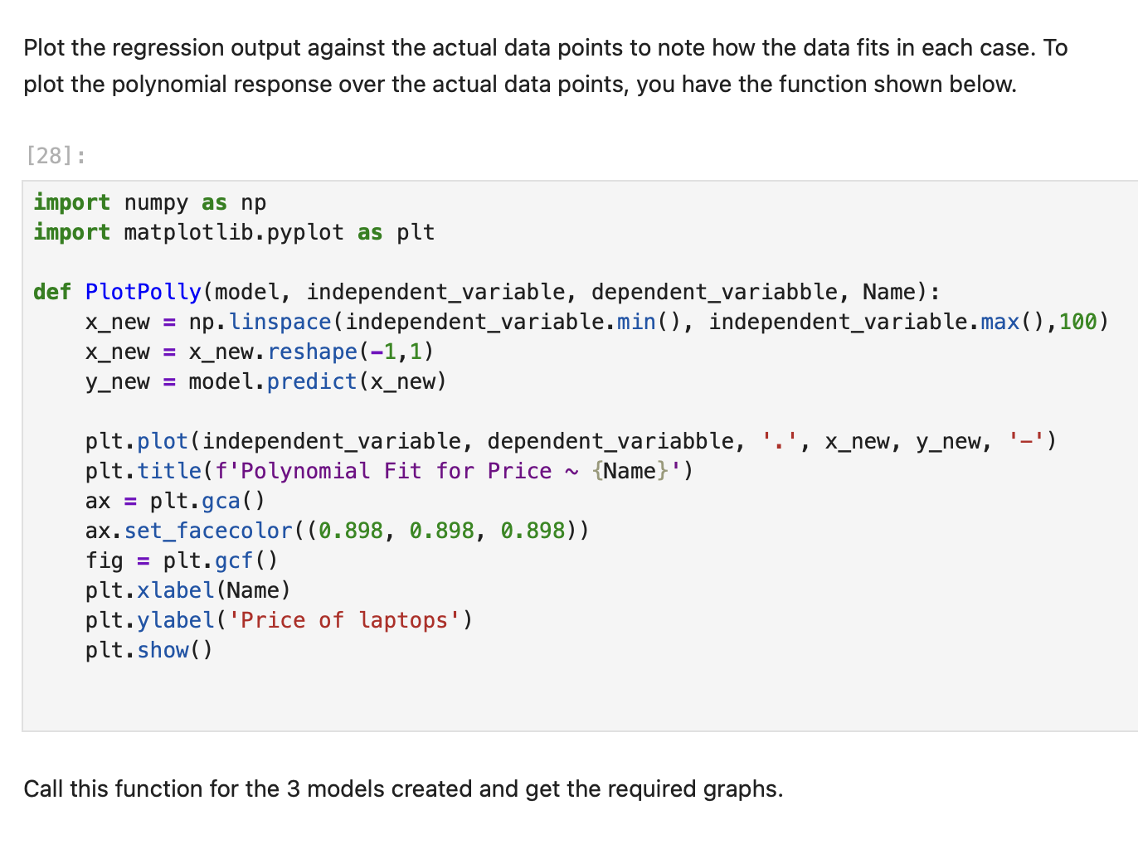
Screenshot file: 13_task3_plotpolly_function_definition.png
The PlotPolly function draws a polynomial curve over the actual data points so each degree can be compared visually.

Lab2_14. Task 3 Calling the plot helper
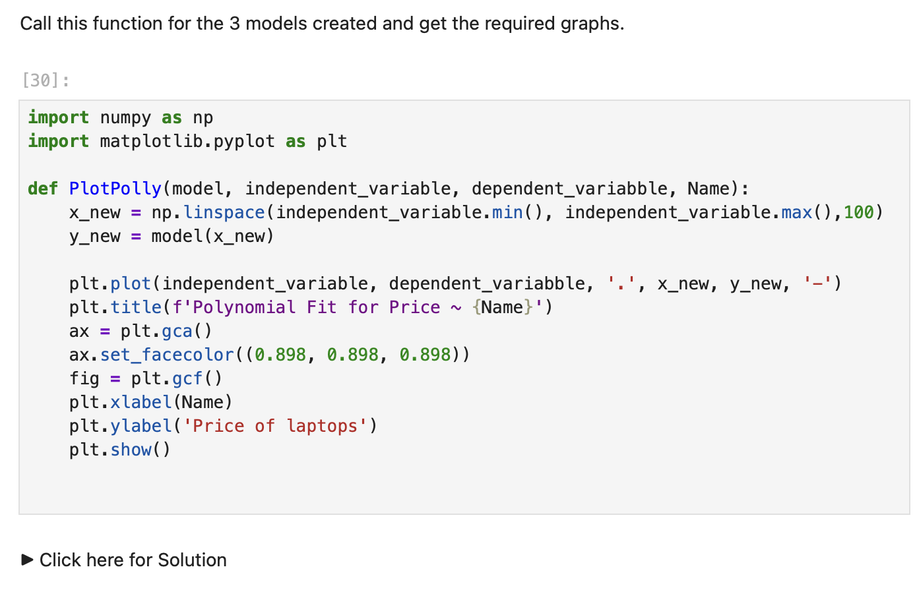
Screenshot file: 14_task3_call_plotpolly_function.png
PlotPolly is called with the fitted model and the CPU_frequency variable to draw the regression curve.

Lab2_15. Task 3 Third degree polynomial fit
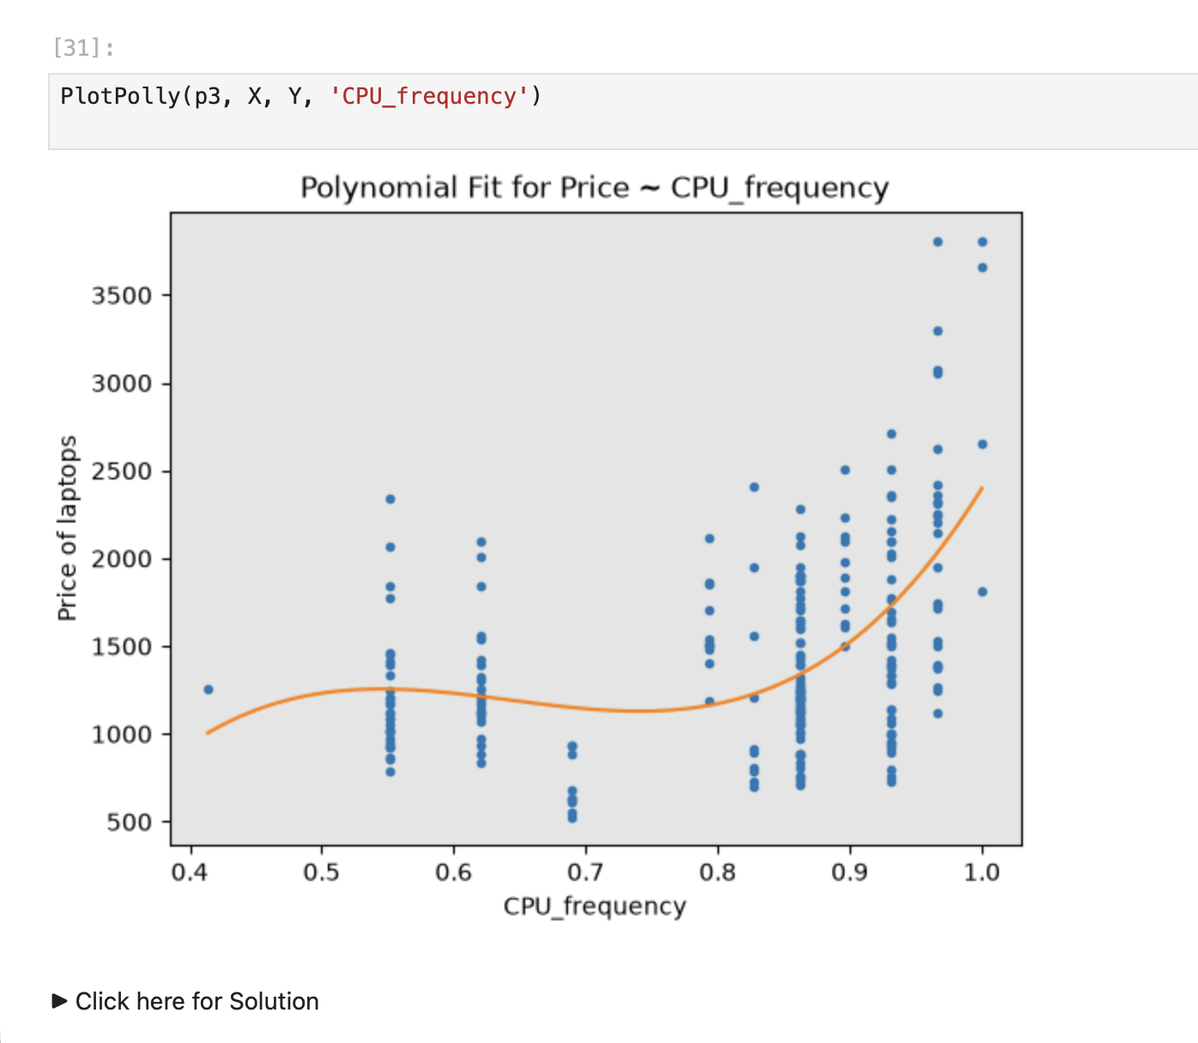
Screenshot file: 15_task3_plotpolly_p3_polynomial_fit.png
The cubic fit is plotted against the data points, which shows how the curve follows the trend.

Lab2_16. Task 3 Fifth degree polynomial fit
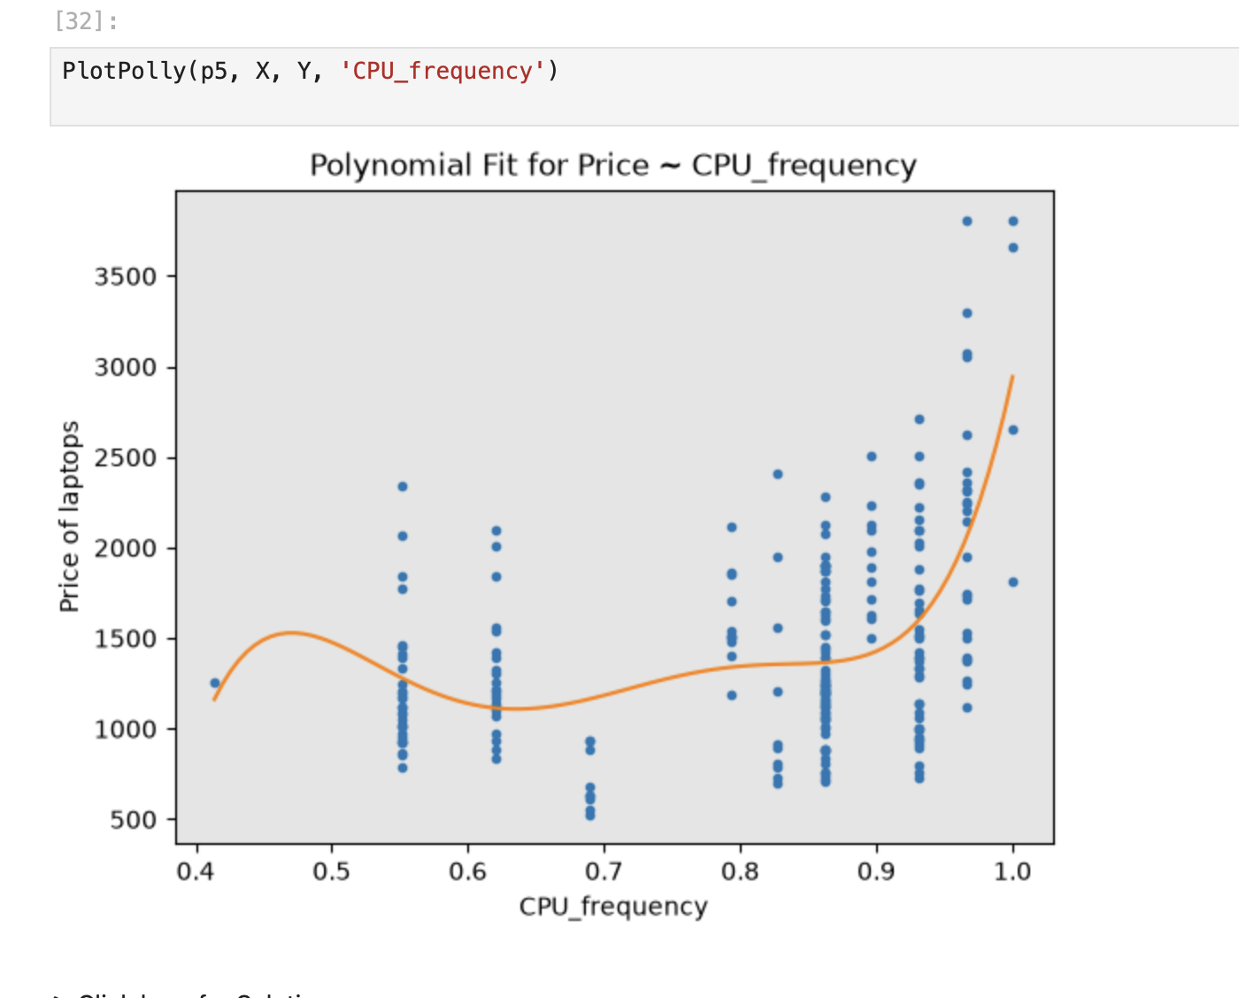
Screenshot file: 16_task3_plotpolly_p5_polynomial_fit.png
The fifth degree curve follows the points more closely, the first sign of the overfitting discussed in the next module.

Lab2_17. Task 3 R squared and error for each polynomial degree
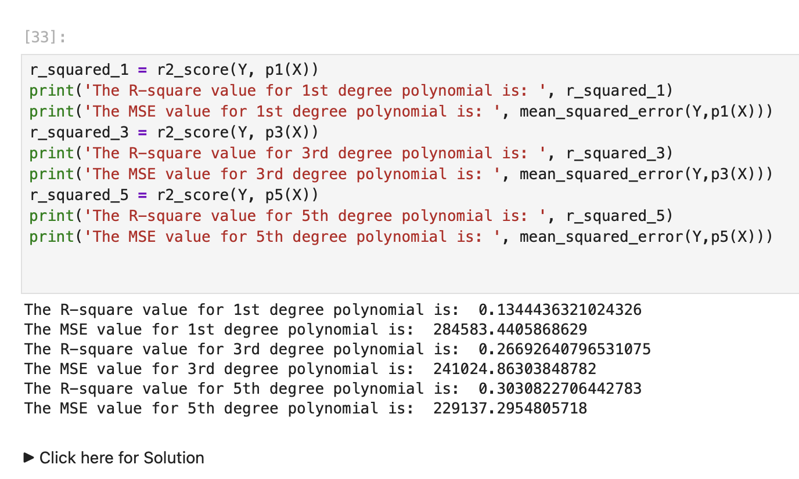
Screenshot file: 17_task3_poly_r2_mse_calculation.png
The R squared and mean squared error of the first, third and fifth degree fits are printed so the degrees can be compared.

Lab2_18. Task 4 Pipeline with scaling, polynomial features and regression
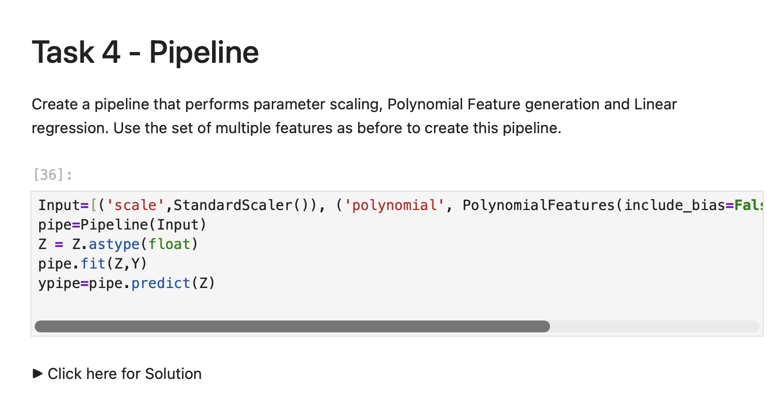
Screenshot file: 18_task4_pipeline_construction_code.png
The pipeline chains StandardScaler, PolynomialFeatures and LinearRegression so all three steps run as one object.

Lab2_19. Task 4 Evaluating the pipeline
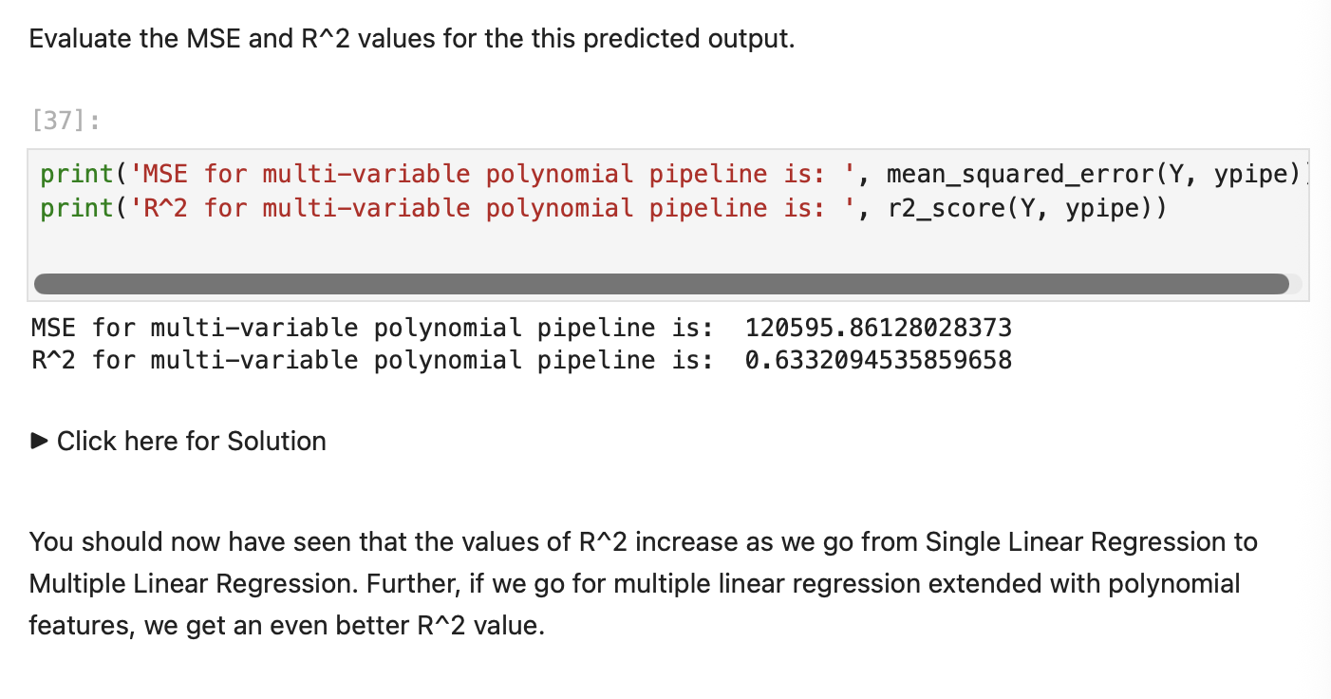
Screenshot file: 19_task4_pipeline_mse_r2_evaluation.png
The pipeline reaches the best R squared of the lab, which confirms that scaling and polynomial features improve on the single variable model.

